**Interior design VR application on a smartphone**

**Motivation**: This app is an interior design virtual reality application that allows you to a wide variety of virtual reality experiences before moving into a new building. So, you can virtually tour your next model home, imagine space before construction, and showcase in your best in design. Through the use of the innovative virtual reality apps and visualization tools, enable user touch controls, move around and envision features and finishes- true to quality and design.

**Business opportunity**: It is an effective, cost-reducing sales and marketing tool that is poised to become the foundation for successful new home and condo sales.

**Google VR SDK for Unity:** Use Unity to build virtual reality apps for Android and iOS.

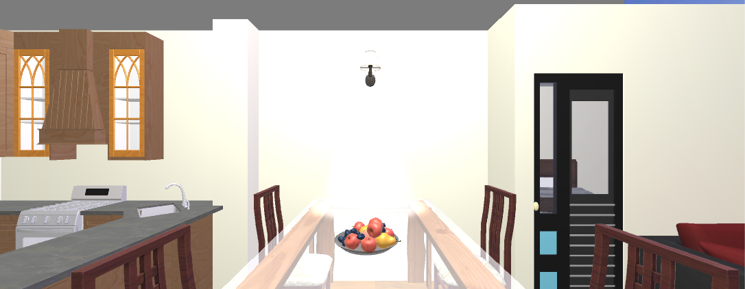 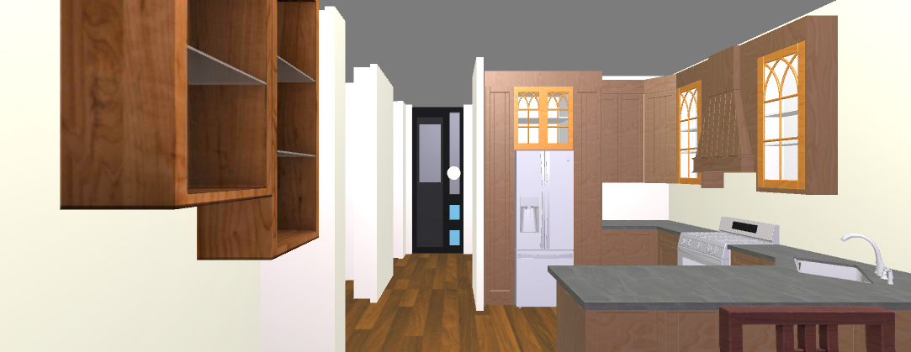

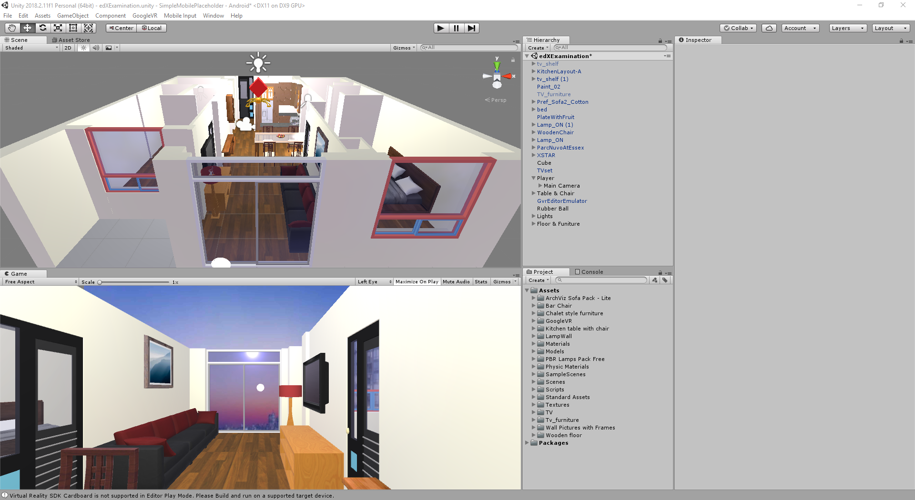

# High Fidelity Game Visuals: Environment Artist

1. Creating a prototype block out from concept art
2. Creating a prototype block out from concept art

Using the concept art for the architecture visualize model, the Level Designer began by identifying key environmental features in the concept art.

Let’s explore the Service Room concept art as an example:

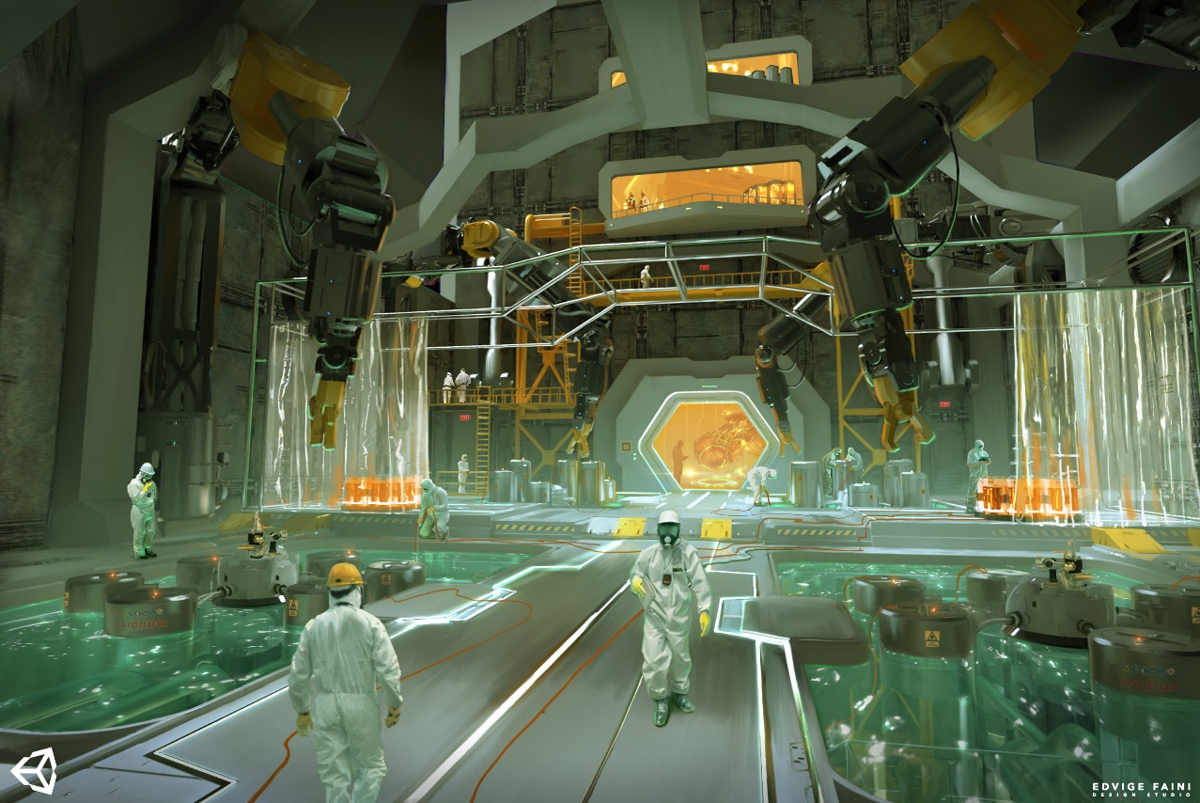

This room concept features:

* Repeating or mirrored structural elements. For example, robot arms with supporting pillars and green pools.
* Repeated or mirroring decorative elements. For example, the translucent plastic curtains and cylindrical pods in the foreground pools.
* Subtle repeated elements. For example, floor trim and wall panels.

1. Identify key environmental features in the goal visualize model.

This will enable you to identify where an Environment Artist would choose to focus detail and time when recreating the room in 3D

Let’s explore the Service Room concept art as an example:

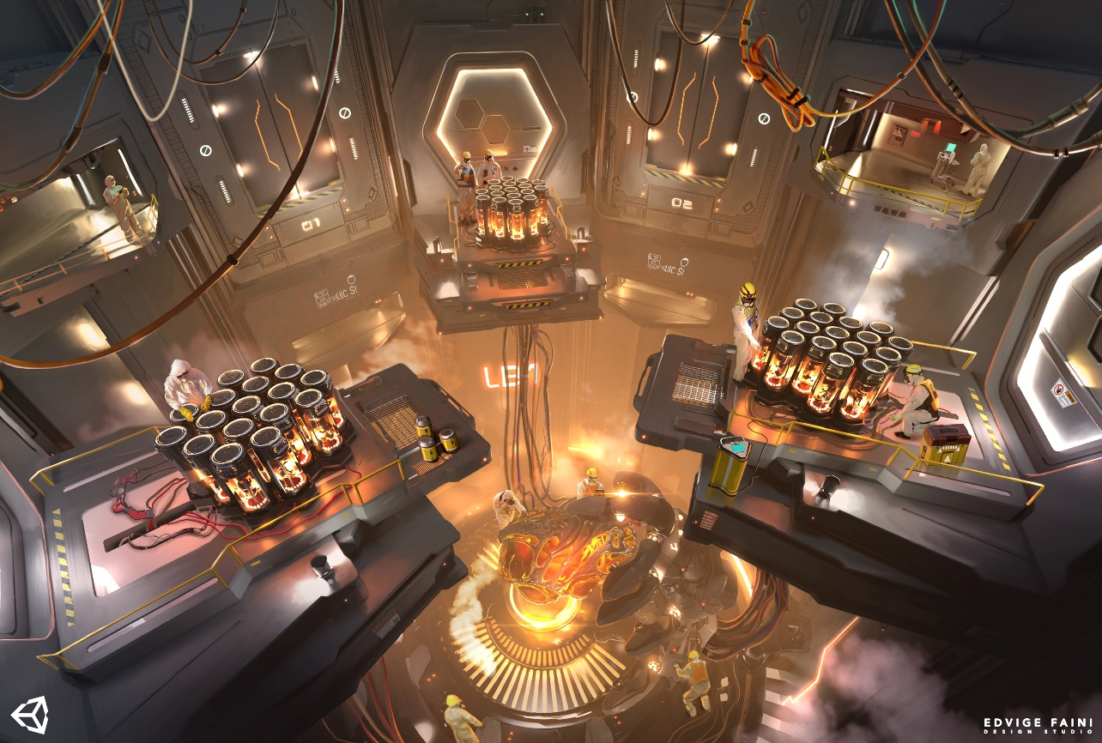

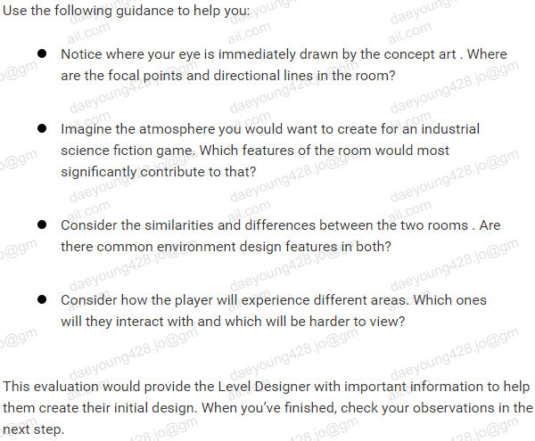

1. The benefits of a modular approach

